Leadership Academy Sessions
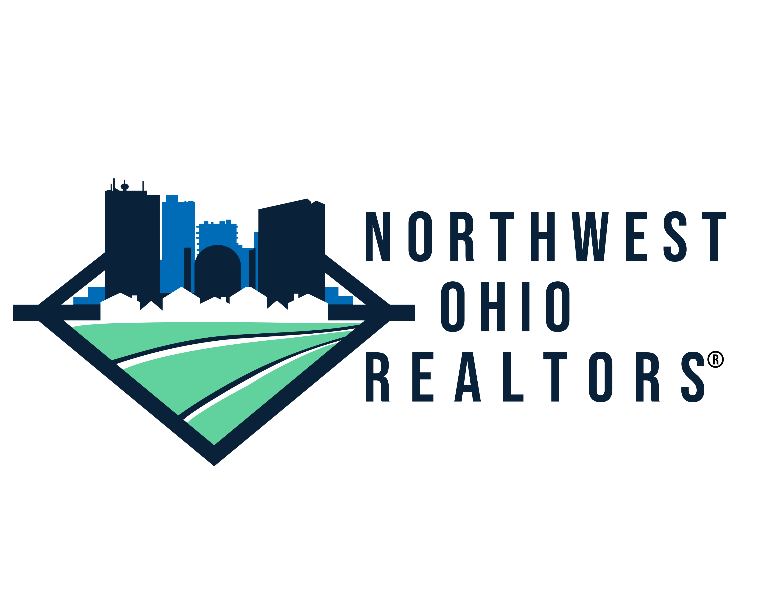

Session Information – Attendance at All Sessions Is Mandatory
Pre-Work
NAR’s REALTORS® Excelling in Association Leadership (REAL) – The online course provides an overview of real estate issues and trends, enhance leadership skills, meeting management, governing documents and policies, legal and regulatory activities, and visioning, planning, and budgeting.
NAR’s Fairhaven: A Fair Housing Simulation – Fairhaven is an interactive online simulation training in which agents confront discrimination in real estate transactions from the point of view of both agent and client.

Kick Off (September 10th 4:00 PM – 7:00 PM) - The opening session of the Leadership Academy will give candidates a chance to connect and begin building relationships. Participants will team up for an escape room challenge at Escape Game Experience, followed by a networking opportunity with the Session 1 Facilitator and members of the Board of Directors.
Session Take-A-Way – New connections and a renewed excitement for the sessions ahead.

Getting to Know You (September 11th 9:00 AM – 4:00 PM) - The program will include interactive icebreaker activities, a DISC assessment, and an evaluation of personal leadership styles, followed by ongoing reflection and development.
Speaker – Marilou Butcher Roth, Marilou Butcher Roth, REALTOR and Professional Business Coach
Session Take-A-Way – A deeper understanding of your own leadership style and strategies for working more effectively with others.

Diversity and Inclusion (October 9th 9:00 AM – 12:00 PM) – Participants will explore the wide range of programs offered by the Ability Center of Greater Toledo and engage in meaningful discussions on Diversity, Equity, Inclusion, and Fair Housing—and their impact within our community.

Speakers – Ability Center of Greater Toledo, Fair Housing Center
Session Take a Way – Greater ability to serve the community with empathy and awareness, foster trust, expand client reach, and build a reputation rooted in inclusivity and respect for civil rights. Participants will also gain a deeper understanding of how a zip code can influence health outcomes.

REALTOR L.E.A.D. Course (October 28th 9:00 – 12:00 AM) - The NAR Leadership Course will cover key aspects of Association leadership, including the dynamics between staff and volunteers, effective meeting participation, and strategies for building consensus.
Speaker – Adorna Carrol, DSA, CRB, ABR, SRS, GRI, SRES and Broker/Owner of Realty 3 of CT
Session Take-A-Way – Enhanced leadership skills and increased confidence in your ability to lead effectively.

Local Politics (November 20th 9:00 AM – 12:00 PM) – In this session, we will introduce you to local REALTOR® Elected Officials, explore the REALTOR® Party, and discuss the vital relationship between the REALTOR® Party, local government, and your real estate business.
Speaker – Brian Dicken, Vice President of Advocacy and Public Policy at the Toledo Regional Chamber of Commerce,
Session Take a Way – A deeper understanding of the issues impacting our local community and the importance of active involvement.

Communication/Public Speaking (December 16th 9:00 AM - 4:00 PM) – Effective communication and public speaking are essential skills for today’s leaders. This program is designed to teach you how to deliver your message clearly and confidently to diverse audiences.
Speaker – Chrys Peterson, News Anchor and Public Speaking Consultant
Session Take a Way - Enhanced public speaking skills and a compelling "elevator" pitch.

Legal Issues (January 8th 9:00 AM – 12:00 PM) – This seminar will provide updates on state and federal regulations, legal issues including license law changes, recent cases, and industry trends aimed at reducing your risks and potentially increasing your earnings.
Speaker – Ohio Realtors Attorney
Session Take-A-Way – 3 hours of Core Law CE and valuable insights to help protect your business.

Association Engagement: Why & How to Get Involved (February 4th 9:00 AM – 12:00 PM) – This session will explore the structure of the Local, State, and National Associations, highlight ways you can get involved, and, more importantly, explain why your involvement matters.
Speaker – Megan Foos, Chief Executive Officer Northwest Ohio REALTORS® and NOR Board Members and Committee Chairs.
Session Take-A-Way – Session Takeaway: A deeper understanding of the Association and enhanced skills for leading more productive meetings.

Ohio REALTORS® & Statehouse Tour (February 24th 7:30 AM – 6:00 PM) – Round-trip transportation will be provided to Columbus, where participants will visit the Ohio REALTORS® headquarters for lunch and presentations by OR staff. Following the visit, you will tour the Statehouse and meet with local legislators.
Speaker – Ohio REALTORS® Staff
Session Take a Way – A deeper understanding of the Ohio REALTORS® and the legislative process, along with valuable connections with local legislators.

Graduation Luncheon (March 10th 11:30 AM – 1:30 PM) – Participants will celebrate the completion of the Leadership Academy with a luncheon at Coopers Hawk Winery.

